Mount Kenya University – Department of Information Technology
Course Code: BIT4107
Course Title: Advanced Mobile Application Development
Student Name: Prince Wilfred Wachira
BIT/2024/56303
Project : Student Management Portal
Environment Setup & Verification
Weekly Objectives & Tasks
- Set up a clean cross-platform mobile ecosystem utilizing Android Studio and the Flutter SDK.
- Connect a physical hardware deployment target over Universal Serial Bus (USB) debugging interfaces.
- Validate the host environment setup via integrated system analytics tools to confirm readiness.
Host System Logs
Running the diagnostic verification pipeline returns zero system blockages, proving absolute environment health:
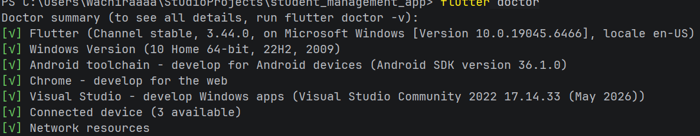
Layout & Routing
Weekly Objectives & Tasks
- Build structured, typed dynamic list objects in Dart to serve as the application's runtime data persistence tier.
- Implement custom form controls paired with strict conditional text state validation.
- Configure a system map utilizing Named Routing parameters to decouple separate application screen objects.
Data Mapping
The local runtime cache utilizes a structured array map collection to handle records dynamically prior to local database storage integration:

Dart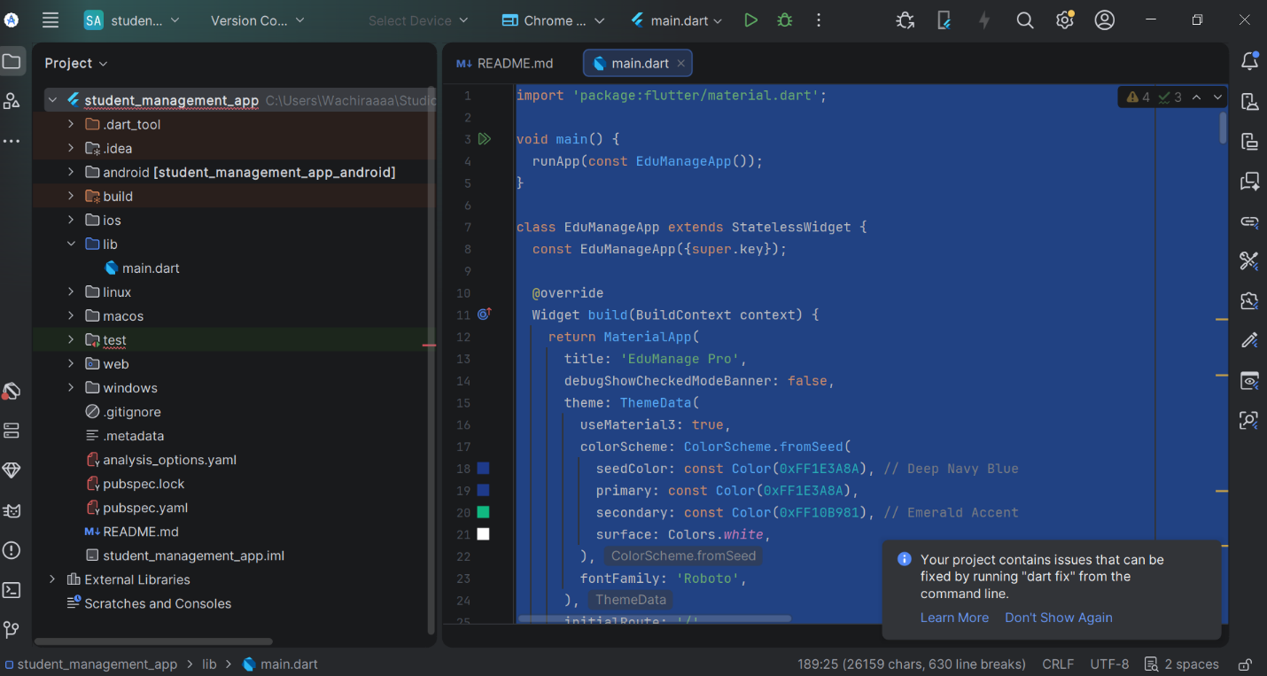
// Mock database mapping configuration
List<Map<String, String>> globalStudentDirectory = [];
Route Configuration
Decoupled navigational handling across views is mapped declaratively using standard application context tracking:
- / Authentication Gateway Screen
- /dashboard System Central Management Hub
- /register Profile Input Registration Form Screen
- /courses Academic Department Index Explorer
- /settings System Node Configurations Panel
High-Fidelity UI Prototyping & Real Device Compilation
Weekly Objectives & Tasks
- Build out a modern, card-based interface prototype containing 5 operational views styled around Material Design 3 guidelines.
- Implement responsive feedback mechanisms (GestureDetector and context snackbars) to give users direct haptic/visual confirmation upon screen interaction.
- Run a native local build execution pipeline (assembleDebug) to cross-compile the application into a functional Android package binary.
Compilation & Deployment Execution Output
The system tracking output documents a successful compilation path targeting the attached hardware device:

PowerShell
PS C:\Users\Wachiraaaa\StudioProjects\student_management_app> flutter run -d R58X30MRTQY
Launching lib\main.dart on SM A155F in debug mode...
Running Gradle task 'assembleDebug'...
Checking the license for package CMake 3.22.1 in C:\Users\Wachiraaaa\AppData\Local\Android\Sdk\licenses
License for package CMake 3.22.1 accepted.
Installing CMake 3.22.1 in C:\Users\Wachiraaaa\AppData\Local\Android\Sdk\cmake\3.22.1... complete.
Gradle build completed successfully.
Installing app-debug.apk onto SM A155F...
Syncing files to device SM A155F...
Application running live [Hot Reload Active].

Technical Defense Framework
When presenting and defending your system during practical logbook assessments, use these definitions to justify your structural decisions:

4.1 UI Input Security Mechanics

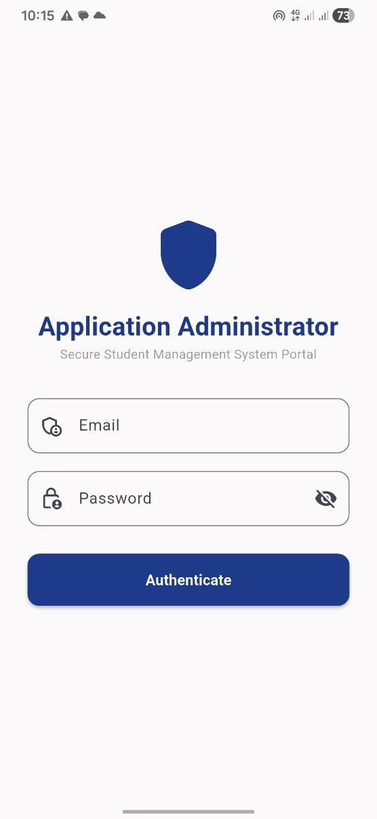
Text input validation is actively coupled to isolated GlobalKey<FormState> instances. This ensures that empty values or unmapped text domains are instantly blocked via real-time logic hooks before the app allows the state array to append any metadata.
4.2 Interaction & Gestures
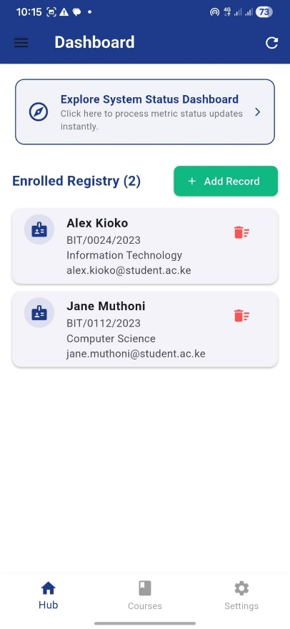
The interactive "Explore Dashboard Panel" at the top of the interface transitions away from static layouts by leveraging a custom wrapping component. This component intercepts touch indicators and actively calculates context confirmations, giving the admin immediate feedback on system integrity.

